**Introduction**

Welcome to **Fitness Tracker – Track Smart. Stay Fit.**, a modern web application designed to simplify and supercharge your fitness journey.

Built using the powerful **MERN stack** (MongoDB, Express.js, React.js, and Node.js), our platform offers a **centralized hub for health-conscious users** to track workouts, monitor nutrition, measure body progress, and stay accountable — all in one place.

Whether you're a beginner or an experienced fitness enthusiast, this app empowers you with:

* 📊 Real-time dashboards
* 🏋️ Custom workout planners
* 🥗 Smart meal and calorie logging
* 📈 Progress analysis tools
* 🔔 Personalized reminders and notifications

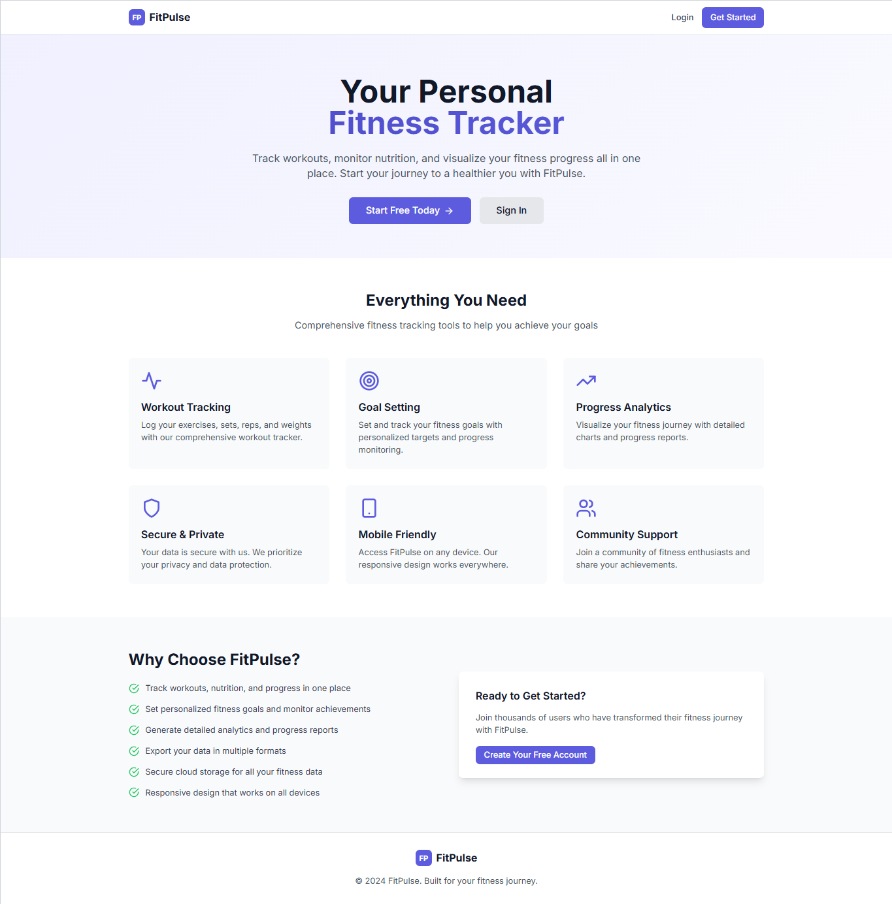

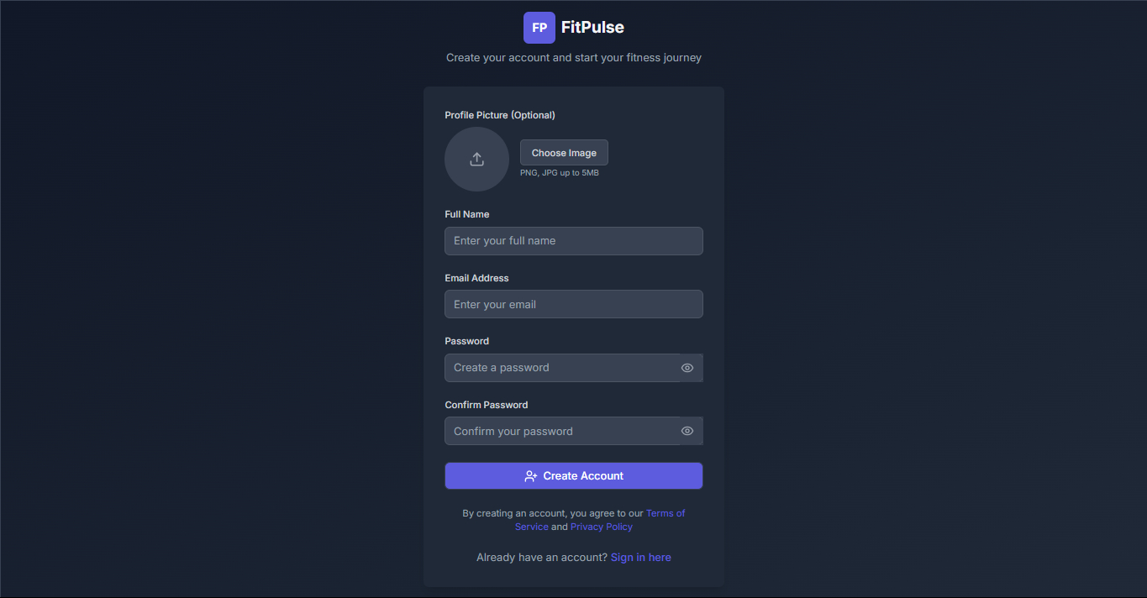

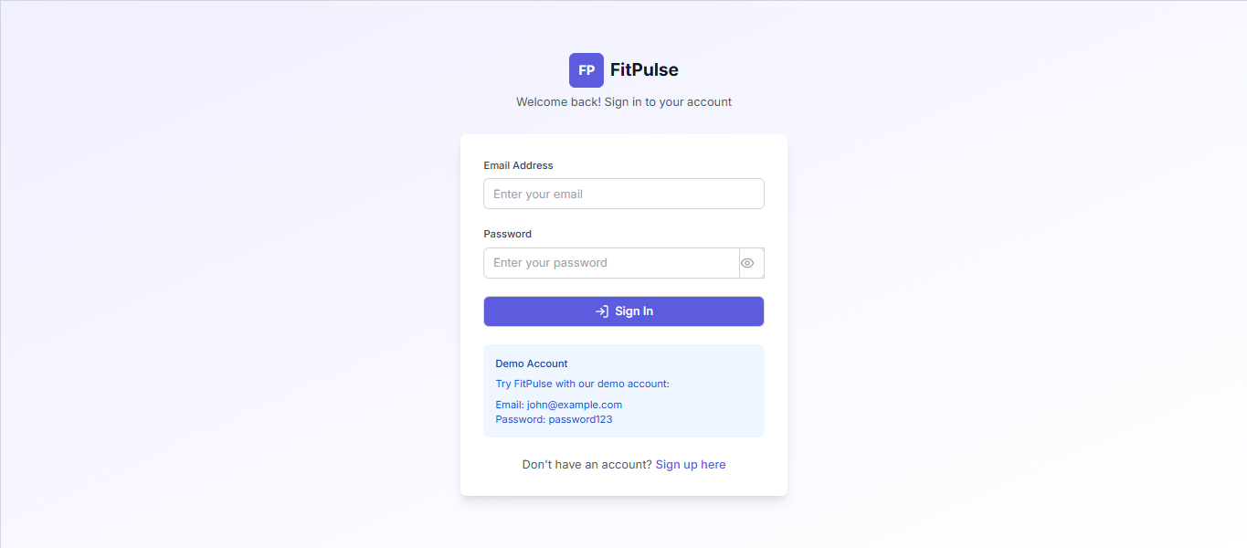

**🔐 User Authentication Module Documentation**

This module handles user registration and login functionality, allowing users to create accounts and access the application securely.

**1. Sign-Up Page**

The **Sign-Up Form** is designed to collect essential user information for account creation.

**🧾 Form Fields:**

| **Field** | **Type** | **Description** |
| --- | --- | --- |
| Username | Text | User's display name (must be unique) |
| Email | Email | Valid email address for account verification |
| Password | Password | Secure password for login |
| Confirm Password | Password | Ensures both password fields match |
| Profile Image | File Upload | Allows user to upload a profile picture |

**✅ Validation:**

* All fields are **required**.
* **Email** must be in a valid format.
* **Password and Confirm Password** must match.
* **Profile Image** must be in JPG, PNG, or WebP format (optional: size limit, e.g., 2MB).

**2. Login Page**

The **Login Form** allows existing users to access their account.

**🧾 Form Fields:**

| **Field** | **Type** | **Description** |
| --- | --- | --- |
| Email | Email | Registered email address |
| Password | Password | Account password |
| Username | Text | Optional: may be used for identification or greeting |

⚠️ Note: Login typically uses **email and password** only, while the username may be used for display purposes post-login.

**✅ Validation:**

* Email and Password are **required**.
* Credentials must match an existing user in the database.
* Invalid login attempts trigger error messages.

**3. Security Considerations**

* Passwords are **hashed** before storing in the database.
* **Validation errors** are shown to the user with clear instructions.
* Proper error handling is implemented to avoid revealing sensitive information.

**Summary of Features**

| **Feature** | **Description** |
| --- | --- |
| Sign-Up | Allows new users to create an account with profile image |
| Login | Authenticates existing users using email and password |
| Field Validation | Ensures user input is secure and follows expected format |
| Profile Image | Optional but helps personalize the user experience |
| Error Handling | Clear messages for invalid entries or failed logins |

**Dashboard**

**🧩 Overview**

The **Dashboard** is the heart of the Fitness Tracker App. It serves as a centralized hub that provides users with a real-time overview of their health journey. Designed for clarity, accessibility, and motivation, the dashboard integrates all key features into a single interface, allowing users to track, manage, and plan their fitness activities effortlessly.

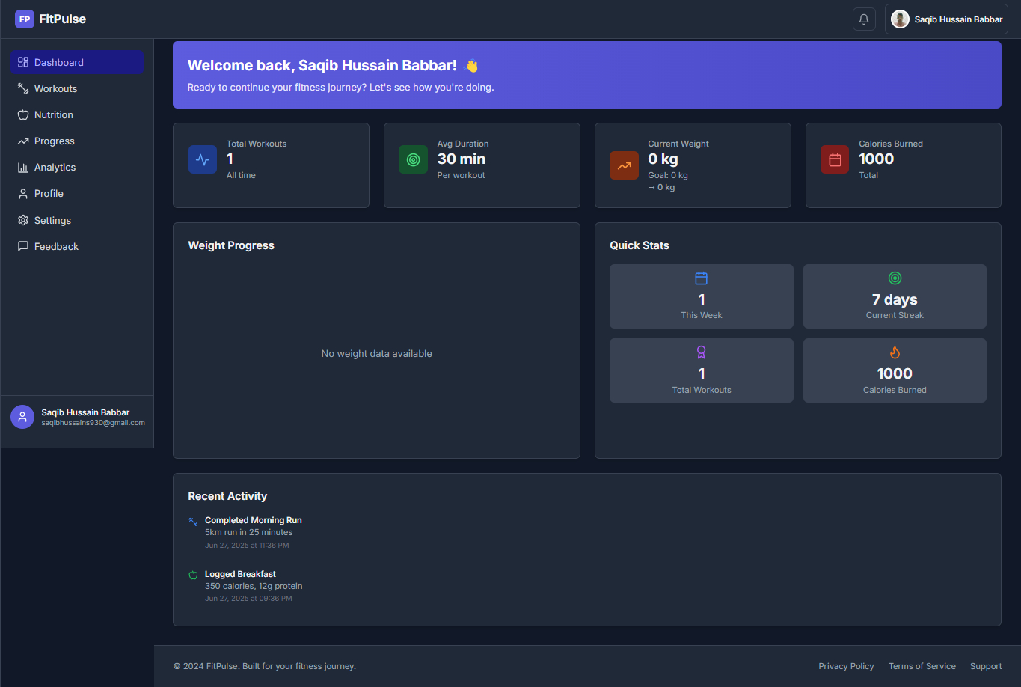

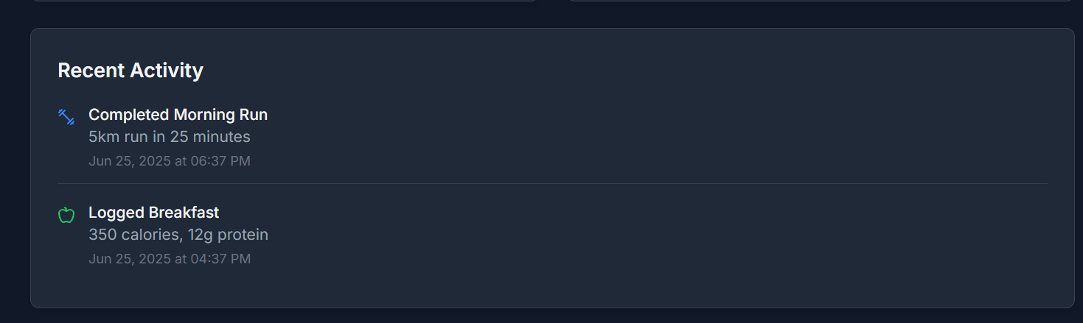

**🔑 Key Features of the Dashboard**

1. **🕒 Workout Hours Tracker**
   * Displays total time spent on workouts for the day and week.
   * Breaks down workout durations by category (e.g., Cardio, Strength, Flexibility).
   * Encourages consistency through daily/hourly targets.
2. **💪 Pre-Workout Status**
   * Shows preparation status before workouts.
   * Includes hydration level, last meal time, and energy readiness.
   * Smart tips like “Take 5 mins warm-up” or “Hydrate before training”.
3. **🔥 Calories Burned**
   * Tracks total calories burned per session and over time.
   * Syncs with workout type and intensity.
   * Visualized using animated progress bars or pie charts.
4. **⚖️ Current Weight Monitor**
   * Displays the user's most recently updated weight.
   * Allows manual or device-synced updates.
   * Includes BMI indicators and health tips based on body weight
5. **📈 Weight Progress Chart**
   * Graphical chart showing weight change over weeks/months.
   * Includes comparison with goals set by the user.
   * Smart indicators for reaching milestones or slipping off track.
6. **📅 Weekly Schedule Panel**
   * Shows a complete week’s plan with scheduled workouts and rest days.
   * Color-coded by type of workout (Cardio, Strength, Rest).
   * Interactive interface: users can click to modify or add new sessions.

**Workout**

**🧩 Overview**

The **Workout Routine Page** allows users to design, log, and track their daily exercise activities. It provides a customizable and structured interface where users can select exercise types, log workout details (e.g., calories burned, reps, duration), and monitor their fitness progress over time.

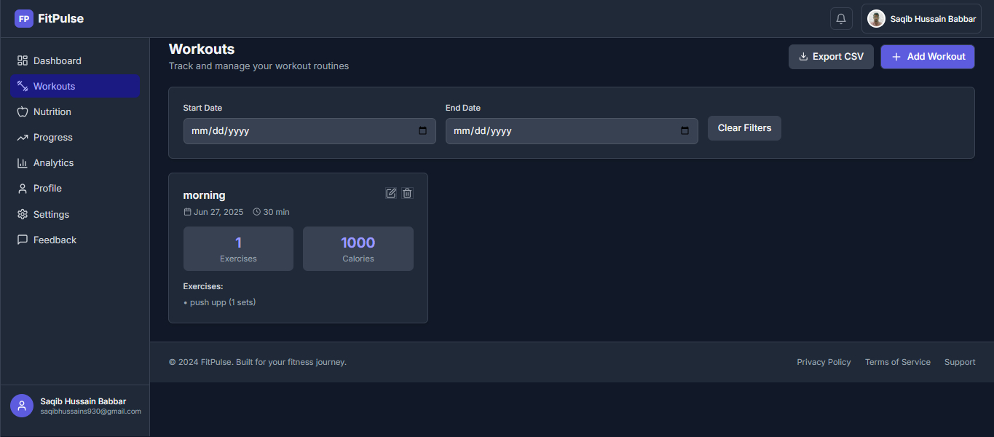

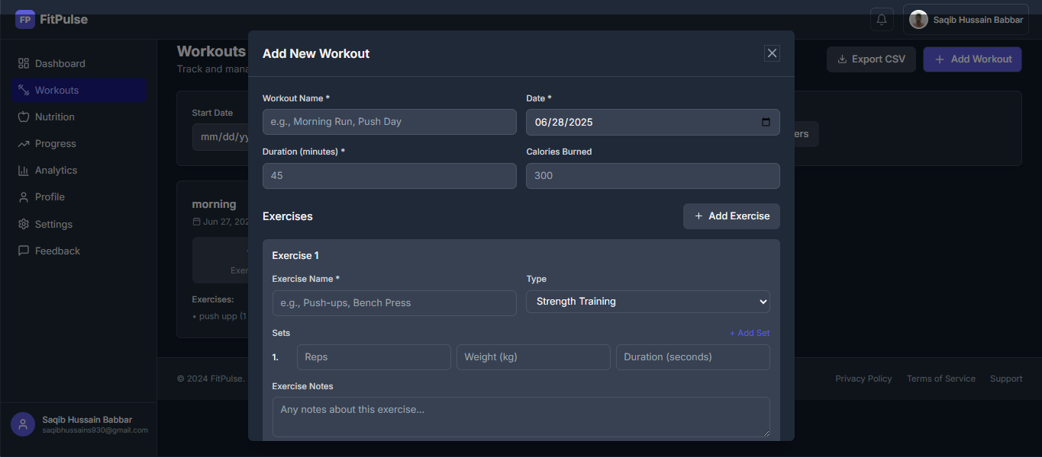

**🔑 Key Features**

1. **📝 Daily Workout Routine Builder**
   * Users can **create a new routine** each day.
   * Exercises can be selected from a predefined list or entered manually.
   * Each workout entry includes:
     + Exercise Name
     + Category (e.g., Cardio, Strength, Flexibility)
     + Duration (in minutes)
     + Sets/Reps (for strength training)
     + Calories Burned
2. **🔥 Calories Burned Logging**
   * Users can **enter estimated calories burned** per exercise session.
   * Optional integration with **smart devices or formulas** to auto-calculate calories based on time and intensity.
   * All calories burned are automatically reflected in the user’s **daily progress stats and dashboard**.
3. **🏃 Cardio Duration Tracker**
   * Automatically records the total time spent on cardio workouts (e.g., running, cycling).
   * Cardio sessions are grouped and displayed separately for clear visibility.
   * Weekly and monthly summaries help users analyze endurance improvement.
4. **🏋️ Strength Training Reps Counter**
   * Tracks **sets and repetitions** for weightlifting exercises.
   * Users can log reps for each set and see cumulative progress.
   * Includes dropdowns for weight selection (e.g., 5kg, 10kg, etc.) if needed.
5. **🧠 Smart Categorization**
   * Exercises are grouped into:
     + **Cardio**
     + **Strength**
     + **Flexibility**
     + **Custom/User-defined**
   * Makes filtering and progress tracking more intuitive.
6. **📊 Progress Visualization**
   * Each routine entry is stored and displayed in progress charts.
   * Users can track improvements in:
     + Duration
     + Reps/sets
     + Calories burned
   * Weekly summaries are generated for review

**Nutrition**

### 🧩 ****Overview****

The **Nutrition Page** is designed to help users track their daily and weekly dietary intake. Users can log individual meals, monitor calorie and nutrient consumption (fat, sugar, fiber, etc.), and visualize their overall diet through interactive charts. This feature promotes healthy eating habits and enhances goal-based fitness planning.

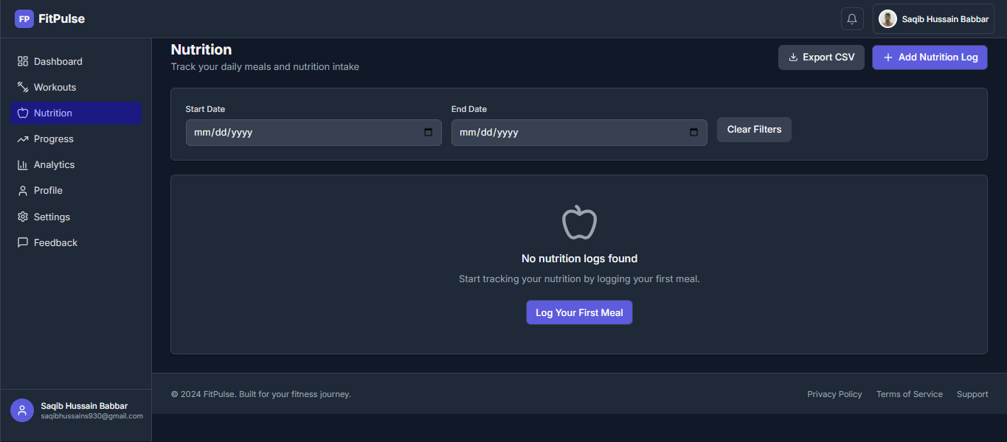

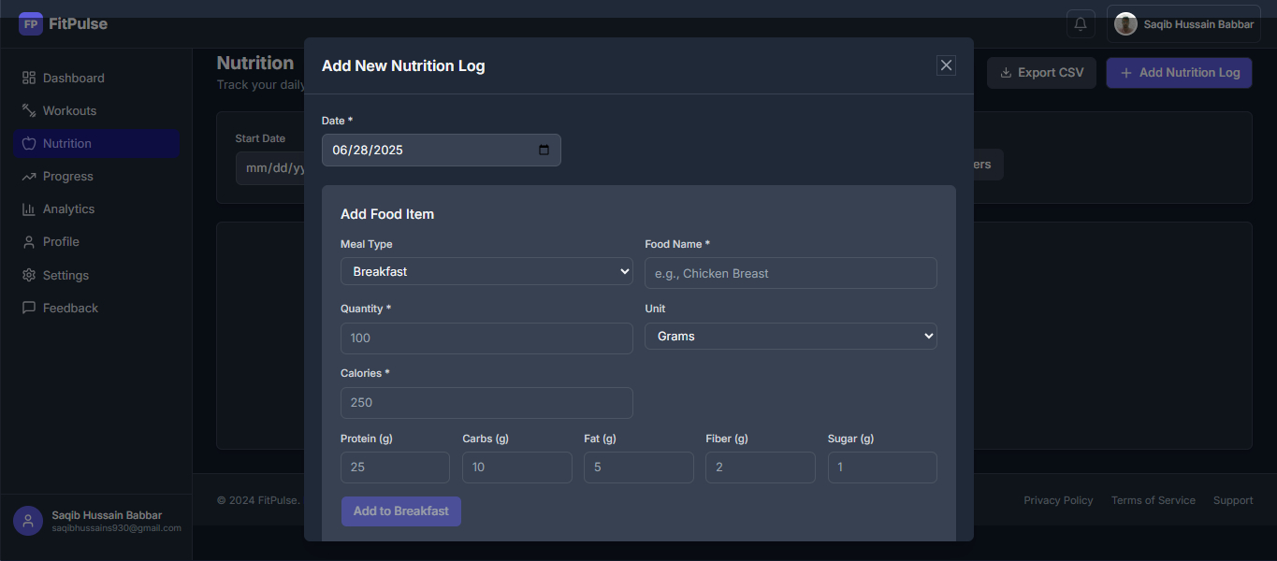



### 🔑 ****Key Features****

### 🍽️ ****Daily Meal Logging****

* + Users can **log meals for each part of the day**, including:
    - Breakfast
    - Lunch
    - Dinner
    - Snacks
  + Each meal entry includes:
    - Food Item Name
    - Portion Size (grams/ml)
    - Calories
    - Macronutrients: **Fat, Sugar, Fiber, Protein, Carbohydrates**
  + Foods can be added from a **predefined list** or entered manually.

### 🔢 ****Nutrient Breakdown****

* + For every meal, users can see a full breakdown of:
    - **Total Calories**
    - **Fat (g)**
    - **Sugar (g)**
    - **Fiber (g)**
    - **Protein (g)**
    - **Carbohydrates (g)**
  + Daily goals are set per user and visually shown as progress bars.

### 📅 ****Weekly Nutrition Chart****

* + A **dedicated weekly chart** shows:
    - Total calories consumed per day
    - Nutrient trends across the week
    - Over/under targets with color indicators
  + Helps users analyze if they’re meeting dietary goals or need adjustments.

### 📊 ****Day View Summary****

* + A separate view displays **all meals logged during the day** in a table format.
  + At the bottom, there is an **auto-calculated total** for:
    - Calories
    - Macronutrients
  + Encourages balance and mindful eating.

**Progress**

🧩 **Overview**

The **Progress Page** empowers users to monitor their physical transformation over time. It records and displays vital body metrics such as weight, body fat percentage, and muscle mass. With visual graphs and smart summaries, users can see how their efforts translate into real results

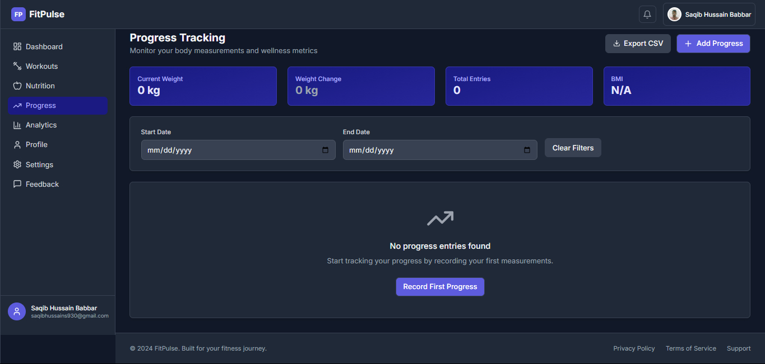

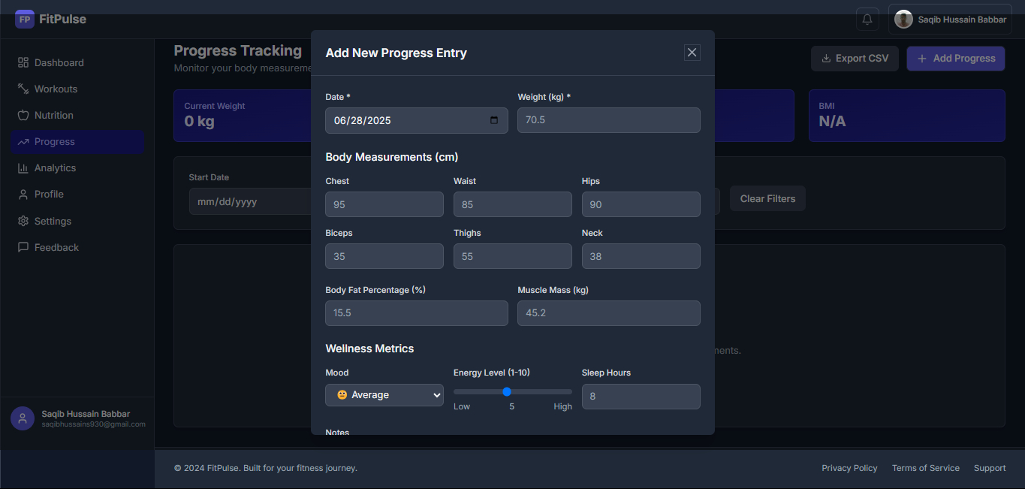

### 🔑 ****Key Features****

### ⚖️ ****Weight Tracking****

* + Users can **log their weight daily, weekly, or monthly**.
  + Entries are saved with timestamps and displayed in a **time-series graph**.
  + Highlights:
    - Initial weight
    - Current weight
    - Target weight (optional)
    - Trend arrows (gain/loss)

### 📏 ****Body Measurements****

* + Users can log key measurements such as:
    - Chest
    - Waist
    - Hips
    - Thighs
    - Arms
    - Neck
  + Measurements are stored and compared to past values to calculate **inch loss/gain**.
  + Graphical comparison for each area.

### 💪 ****Muscle Mass & Body Fat %****

* + Optional fields for advanced tracking:
    - **Body Fat Percentage** (manual input or via smart devices)
    - **Muscle Mass**
  + Helps users assess:
    - Fat loss vs. muscle gain
    - Progress beyond just weight numbers

### 📊 ****Progress Visualization****

* + All data is visualized using dynamic and interactive charts.
  + Separate graphs for:
    - Weight over time
    - Body fat % over time
    - Muscle mass trends

**Analysis**

### 🧩 ****Overview****

The **Progress Analysis** system is a smart feature that interprets users’ logged data across the app to give meaningful insights into their fitness journey. It connects different data points—like workout intensity, weight change, nutrition, and body stats—to deliver clear, visual progress reports and personalized feedback.

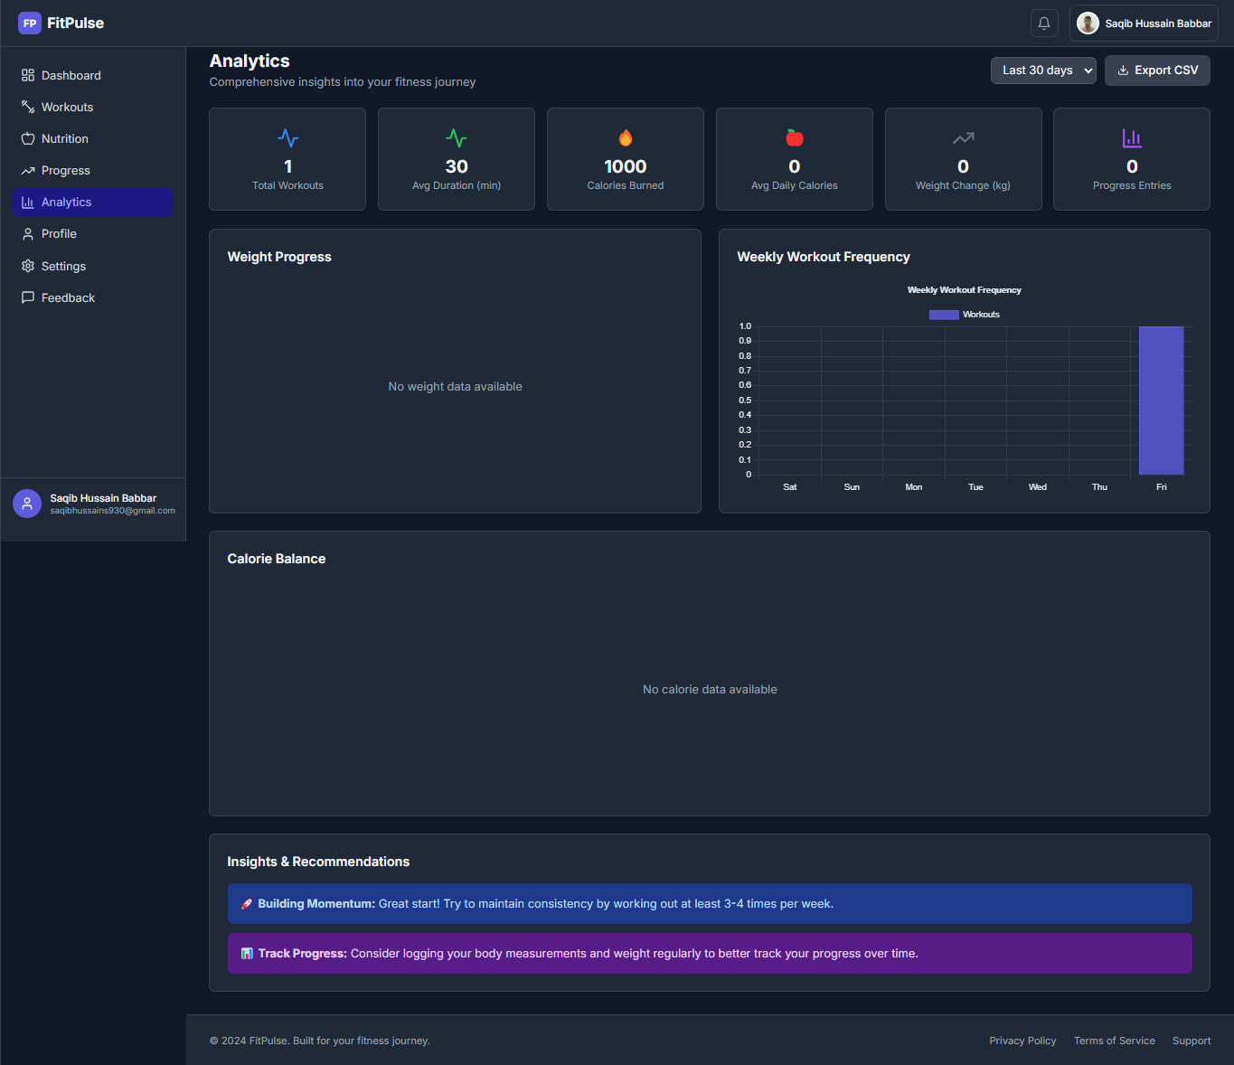

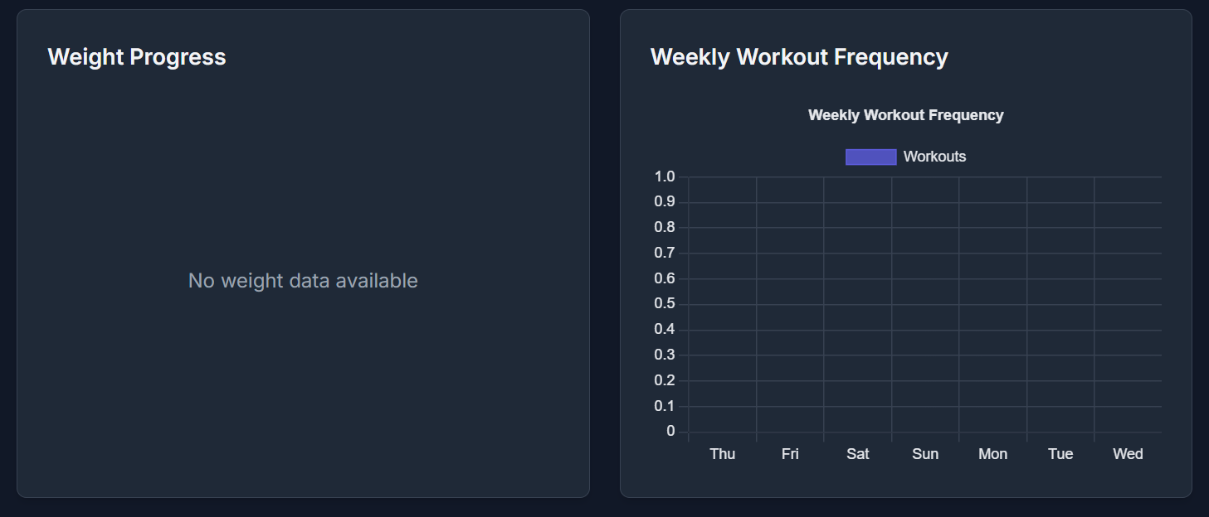

### 🔎 ****What It Analyzes****

### 📈 ****Weight & Body Composition Trends****

* + Compares **initial vs current weight** over time.
  + Tracks **body fat %**, **muscle mass**, and **overall body measurements**.
  + Detects patterns: fat loss, muscle gain, plateaus.

### 🧮 ****Workout Consistency & Impact****

* + Weekly/monthly activity summaries:
    - Total workout hours
    - Calories burned
    - Cardio vs Strength ratio
  + Correlates effort with physical change (e.g., “More cardio led to higher fat loss”).

### 🥗 ****Diet & Nutrition Balance****

* + Summarizes **calorie intake vs burn rate**.
  + Highlights over- or under-consumption of:
    - Fat
    - Sugar
    - Fiber
    - Protein
  + Tracks diet quality and its effect on weight/muscle stats.

### 📅 ****Weekly Summary Dashboard****

* + All progress is displayed in an **auto-generated weekly report**.
  + Includes:
    - Weight change graph
    - Workout summary
    - Nutrient chart

**Profile page**

### 🧩 ****Overview****

The **Profile Page** allows users to personalize their fitness experience by setting personal attributes, fitness goals, and enabling smart reminders. This module acts as the configuration center for the user’s journey across the app, ensuring all features respond to the user’s unique data and preferences.

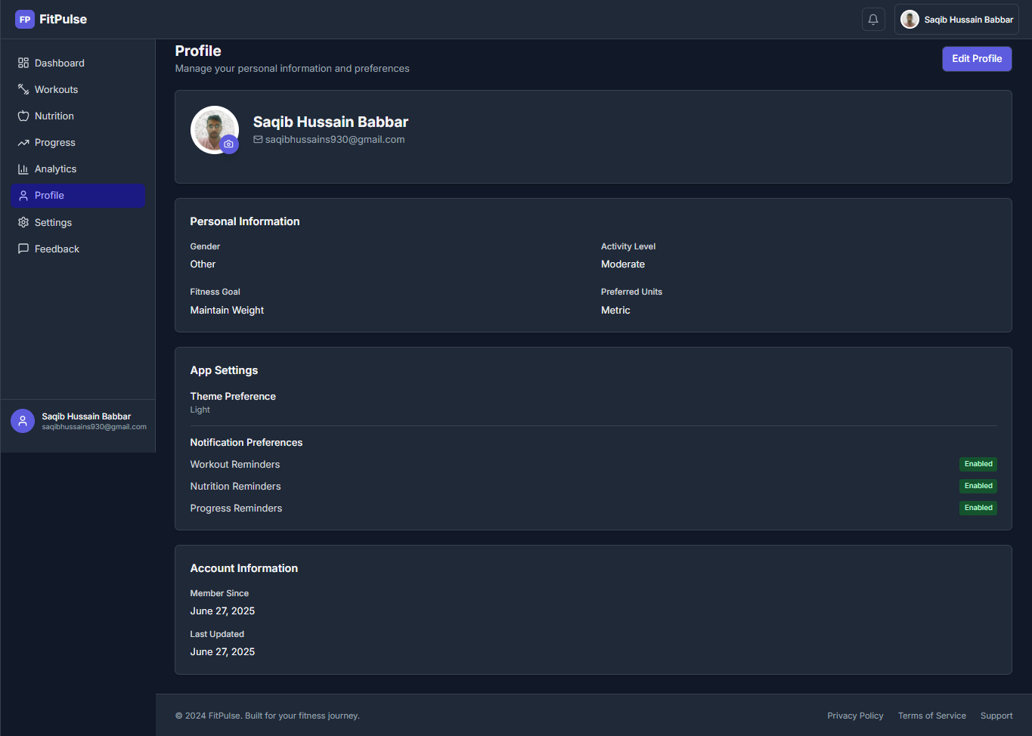

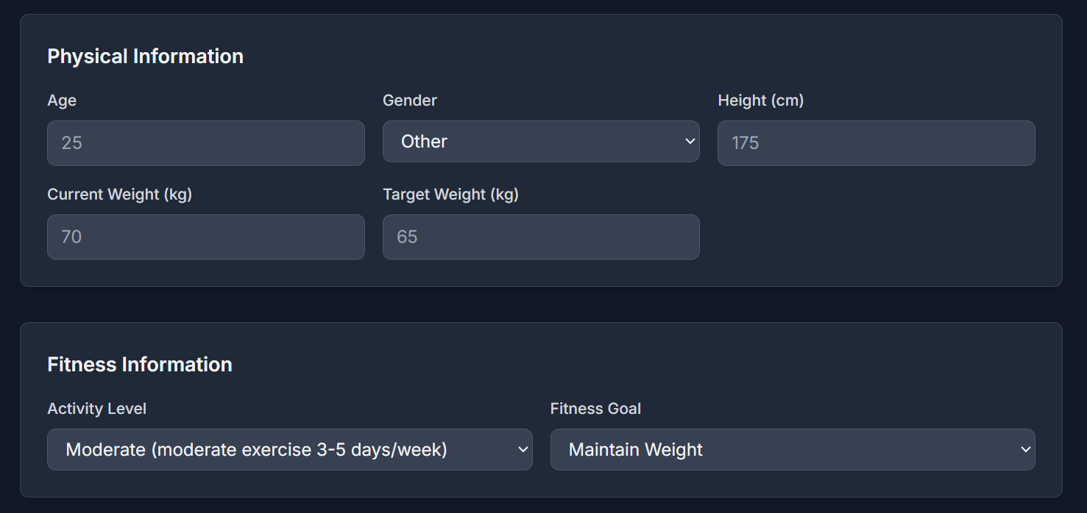

### 🔑 ****Key Features****

### 🙍‍♀️ ****Basic User Information****

* + Fields to input:
    - **Name**
    - **Gender**
    - **Age** (optional)
    - **Height**
    - **Fitness Level** (Beginner / Intermediate / Advanced)
  + Stored securely in the backend and used for calculating BMI, calorie needs, etc.

### ⚖️ ****Current & Target Weight****

* + Users can log:
    - **Current Weight** (updates can be synced with the Progress Page)
    - **Target Weight**
  + Used by the app to determine weekly weight goals and feedback

### 🔔 ****Reminder Settings****

* + Users can **enable or disable automated reminders** via toggle switches:
    - ✅ **Workout Reminder**
    - ✅ **Progress Check Reminder**
    - ✅ **Nutrition Log Reminder**
  + Reminders can be daily, weekly, or user-defined
  + Notifications appear in-app and can optionally sync to device notifications (mobile)

**Feedback**

### 🧩 ****Overview****

The **Feedback Page** empowers users to communicate with the development team by submitting feedback, **reporting bugs**, or **requesting new features**. This fosters a collaborative environment where the app continuously evolves to meet user needs.

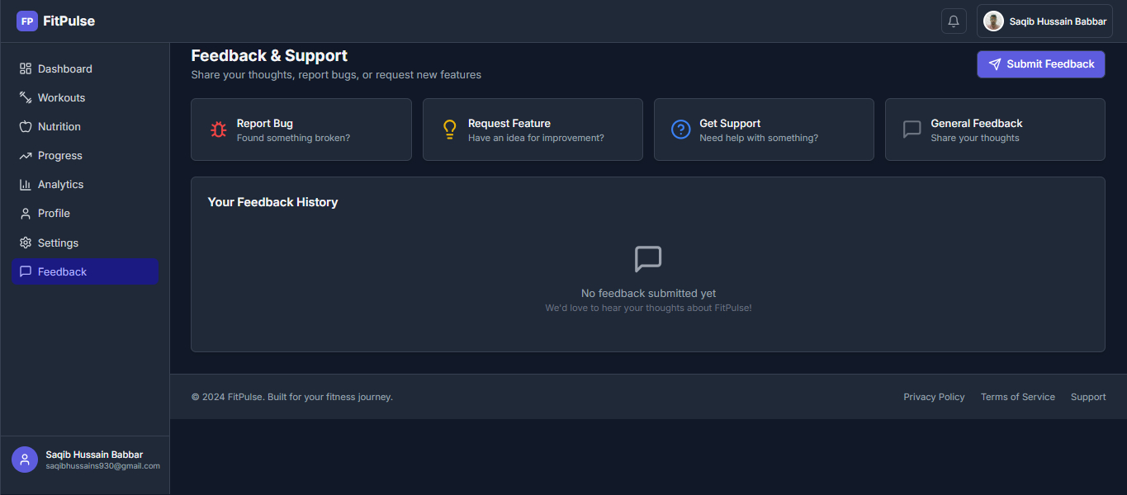

### • 1🐞 ****Bug Reporting****

* Users can select "Report a Bug" to inform the team about:
  + App crashes
  + Feature malfunctions
  + UI issues or errors
* Suggestions to include:
  + Step-by-step description of the issue
  + What device/browser they were using

### •2 ✨ ****Request a Feature****

* Users can propose new features such as:
  + Water tracker
  + Step counter
  + AI fitness coach
* Requests are sent to the admin dashboard or database for review and prioritization

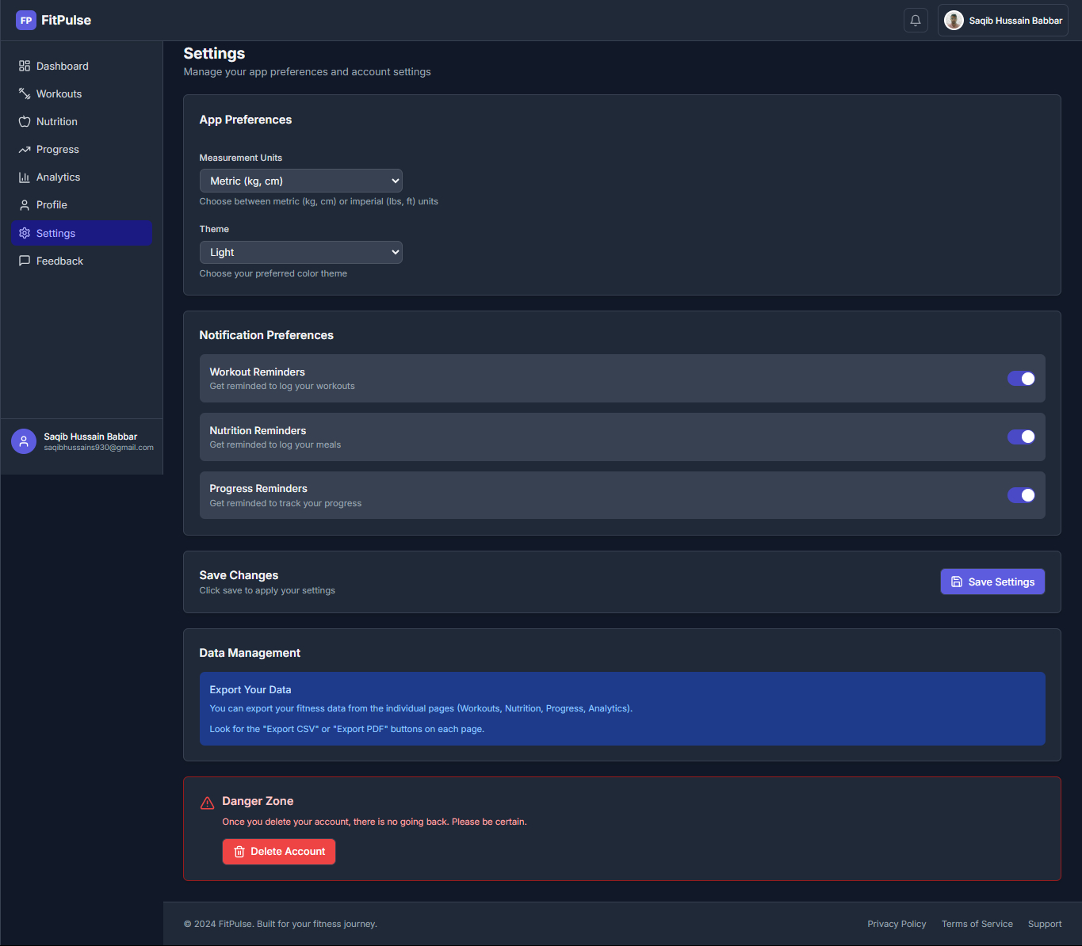

**🔧 Project Settings Documentation**

This section of the app allows users to personalize their experience through various preferences and data management options.

**1. Measurement Unit Settings**

* Users can select their preferred measurement units:
  + **Weight Unit**: Kilograms (kg)
  + **Height Unit**: Centimeters (cm)
* These units are used across the app in workouts, nutrition tracking, and progress charts.

**2. Theme Mode**

* Users can switch between:
  + **Light Mode**: For brighter interface
  + **Dark Mode**: For a low-light environment
* This setting enhances user comfort and accessibility.

**3. Notification Preferences**

Allows the user to manage reminders for different sections:

* **Workout Reminder**: Receive notifications to stay consistent with workout routines.
* **Nutrition Reminder**: Alerts for meal times or nutrition tracking.
* **Progress Reminder**: Encourages users to log their progress regularly.

**4. Save Changes Button**

* After modifying settings (units, mode, notifications), the user must press **“Save Changes”** to apply and store preferences.

**5. Data Management**

This section enables control over the user's data in the app:

* **Export Data to PDF**: User can export their complete data (workouts, nutrition logs, progress reports) into a downloadable **PDF document**.
* **Delete Account**:
  + Button to permanently delete the account.
  + Includes a **warning notification** to confirm the action to prevent accidental deletion.

**Summary of Actions**

| **Feature** | **Description** |
| --- | --- |
| Measurement Unit | Switch between kg/cm |
| Theme Mode | Toggle between light and dark themes |
| Notifications | Manage reminders for workouts, nutrition, and progress |
| Save Changes | Apply and store settings |
| Export Data to PDF | Download all personal app data in PDF format |
| Delete Account | Permanently delete account with confirmation notification |

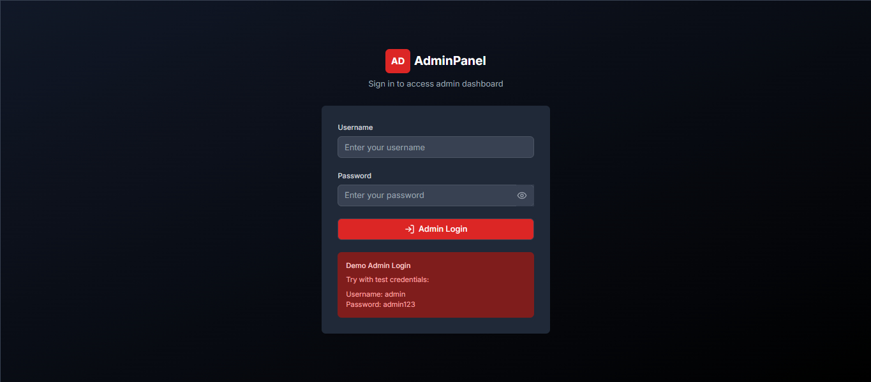

:

**🛡️ Admin Panel Login Page Documentation**

This page provides a secure entry point for administrators to access the backend **Dashboard** of the application.

**🔐 Purpose**

To restrict access to administrative functionalities by allowing only authorized admin users to log in and manage the system.

**1. Login Form Structure**

**🧾 Form Fields:**

| **Field** | **Type** | **Description** |
| --- | --- | --- |
| Email | Email | Admin’s registered email address |
| Password | Password | Secure password to authenticate the admin |

You may optionally include a **"Remember Me"** checkbox and **"Forgot Password"** link.

**2. Validation Rules**

* Both fields are **required**.
* Email must be in valid format.
* Password must meet security criteria (e.g., min 6 characters).
* If credentials are incorrect, an **error message** should be displayed.

**3. Authentication Logic**

1. Admin submits email and password.
2. System checks credentials against the **admin users database**.
3. If authenticated:
   * Redirect to **Admin Dashboard**.
4. If failed:
   * Show error message: "Invalid email or password".

**4. Security Measures**

* Passwords are **hashed** using secure algorithms (e.g., bcrypt).
* Admin routes are protected with **middleware/auth guard** (e.g., Laravel’s auth:admin).
* Login form should be protected with **CSRF tokens**.
* Rate-limiting or throttling for repeated login attempts.

**5. Post-login Redirect**

Upon successful login, admin is redirected to:

bash

CopyEdit

/admin/dashboard

The dashboard includes:

* Quick statistics
* User management
* Feedback control
* Product/inventory controls
* Other relevant features

**✅ Summary Table**

| **Feature** | **Description** |
| --- | --- |
| Admin Login Form | Secure login for admin users |
| Email/Password Fields | Required, validated inputs |
| Error Handling | Clear message for invalid credentials |
| Middleware Protection | Ensures only admins access protected routes |
| Dashboard Redirect | Successful login leads to admin dashboard |

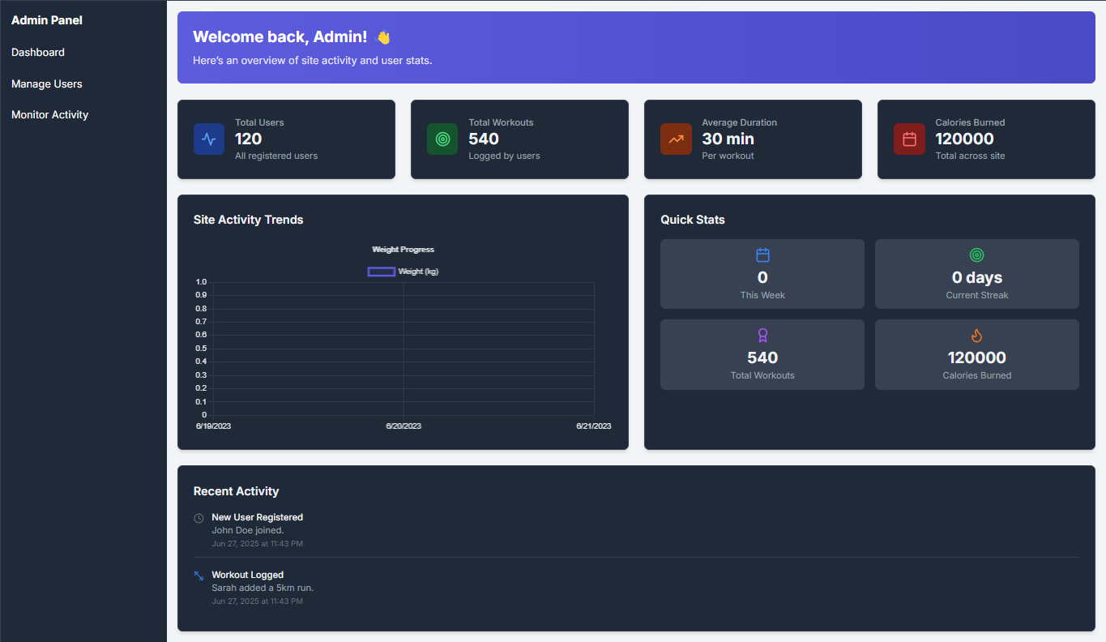

**🧭 Admin Dashboard Documentation**

The **Admin Dashboard** is the central hub for managing and monitoring all activities related to user workouts, nutrition tracking, and progress analytics. It provides a comprehensive overview with real-time insights and statistics.

**🧩 1. Dashboard Overview Sections**

**✅ A. User & Workout Overview**

| **Section** | **Description** |
| --- | --- |
| **Total Registered Users** | Displays the total number of users who have signed up. |
| **Total Workouts Logged** | Shows how many workout entries have been recorded by users. |
| **Average Workout Duration** | Calculates the average time (in minutes) spent per workout session. |
| **Total Calories Burned** | Shows the cumulative calories burned by all users. |

**📊 B. Weight Progress Chart**

* Displays a **graph/chart** representing:
  + Weight change over time (weekly or monthly).
  + Helps admins track overall user fitness progress trends.
* Built using a **line or area chart** for visual clarity.

**⚡ 2. Quick Stats Section**

This section gives a rapid view of current activity and summaries:

| **Stat** | **Description** |
| --- | --- |
| **Total Workout Time** | Shows the cumulative workout time across all users (in min/hr). |
| **Total Workouts** | Number of workout sessions logged. |
| **Recent Workouts** | List of the most recently logged workouts (user + activity details). |
| **Recent Nutrition Logs** | Displays recent food/nutrition entries by users. |
| **Recent Registered Users** | Shows names and dates of the latest users who signed up. |

**🔐 3. Access & Interactivity**

* Only admins can view the dashboard via protected route (e.g., /admin/dashboard).
* Data is updated **in real-time** or **refreshed automatically**.
* Each card/section may have a link to view detailed reports (e.g., View All Users, View All Workouts).

**📈 4. Data Sources**

* All stats are pulled from backend databases:
  + users table (for registration info)
  + workouts table (for logs, duration, calories)
  + nutrition table (for meal tracking)
  + progress table (for weight tracking)

**🗂️ Summary Table**

| **Feature** | **Description** |
| --- | --- |
| Total Registered Users | Count of all users in the system |
| Total Workouts | Total workout sessions tracked |
| Average Duration | Average workout length per session |
| Total Calories Burned | Combined calories burned by all users |
| Weight Progress Chart | Graph showing user weight trends |
| Total Workout Time | Sum of all workout durations |
| Recent Workouts | Latest workouts logged by users |
| Recent Nutrition Logs | Latest food entries from users |
| Recent Registered Users | List of most recent user signups |

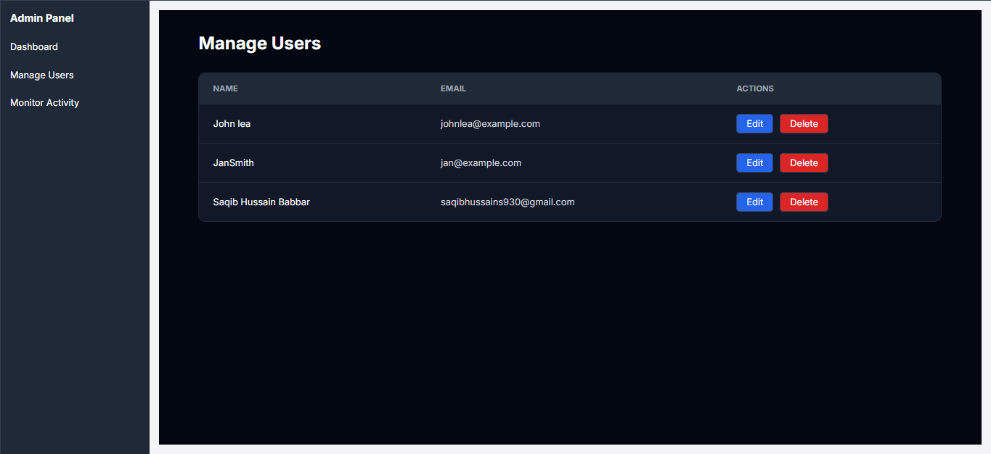

**👥 Admin – Manage Users Page Documentation**

This page allows the administrator to **view**, **edit**, **delete**, and **manage all registered users** in the application.

**📌 1. Page Purpose**

The **Manage Users** section provides complete control over user accounts. Admins can perform **CRUD operations** (Create, Read, Update, Delete) to ensure proper user management.

**📋 2. Main Features**

**✅ A. Total Registered Users**

* Displays the total number of users currently registered.
* Shown at the top of the page as a summary counter.

**🔍 B. User List Table**

Each user is listed in a table with the following columns:

| **Field** | **Description** |
| --- | --- |
| ID | Unique user ID |
| Username | User’s display name |
| Email | Registered email address |
| Profile Image | User's uploaded profile picture |
| Role | (e.g., user, admin) |
| Actions | Edit, View, Delete buttons |

**🛠️ 3. CRUD Operations**

| **Operation** | **Functionality** |
| --- | --- |
| **View** | Opens a modal or new page to show complete user profile and activity details |
| **Edit** | Allows admin to update username, email, role, and profile image |
| **Delete** | Permanently removes the user from the database after confirmation |

⚠️ A **confirmation modal** is shown before delete to prevent accidental actions.

**🔒 4. Security and Access**

* Only users with **admin privileges** can access this page.
* All operations are secured with **authentication and authorization middleware**.

**🔄 5. Additional Functionalities (Optional)**

* **Search Bar**: To find users by name or email.
* **Pagination**: To handle large user lists.
* **Export Users**: Option to export user data to CSV or PDF (if needed).

**📈 Summary Table**

| **Feature** | **Description** |
| --- | --- |
| Total Users Count | Shows the number of registered users |
| View User | Displays full user profile and activity |
| Edit User | Admin can change user details |
| Delete User | Admin can remove user with confirmation |
| Role Management | (Optional) Change user roles (e.g., promote to admin) |
| Access Control | Secured via middleware and admin-only access |

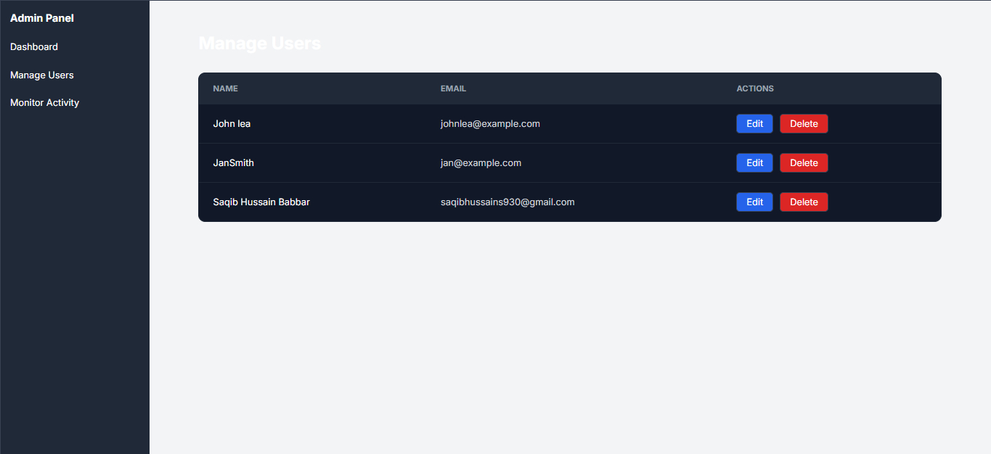

Team Member for this project is   
 1 Saqib Hussain

2 Ather Hussain

3 Aqib

4 Aisha

5 Kinza agha